Azure Devops Yaml

Jayanth R

ACE11696

This is my BitBucket Repository containing my dotnet application.

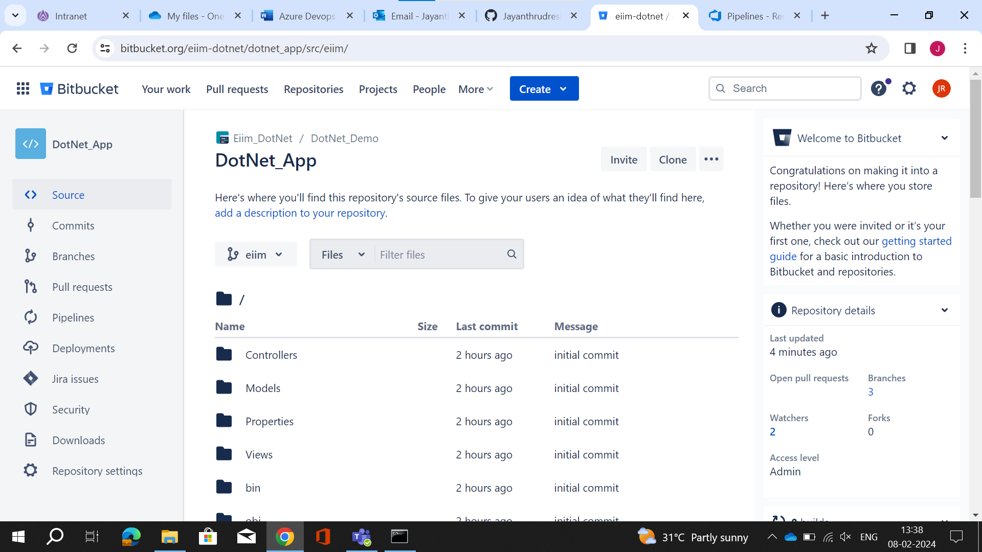

I'm creating a pipeline for accessing my repository to build and deploy it.

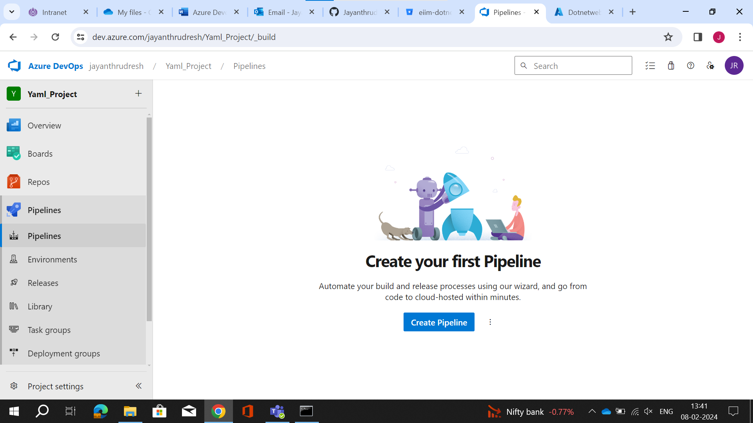

Select Your Private repository as your project is private in Azure Devops.

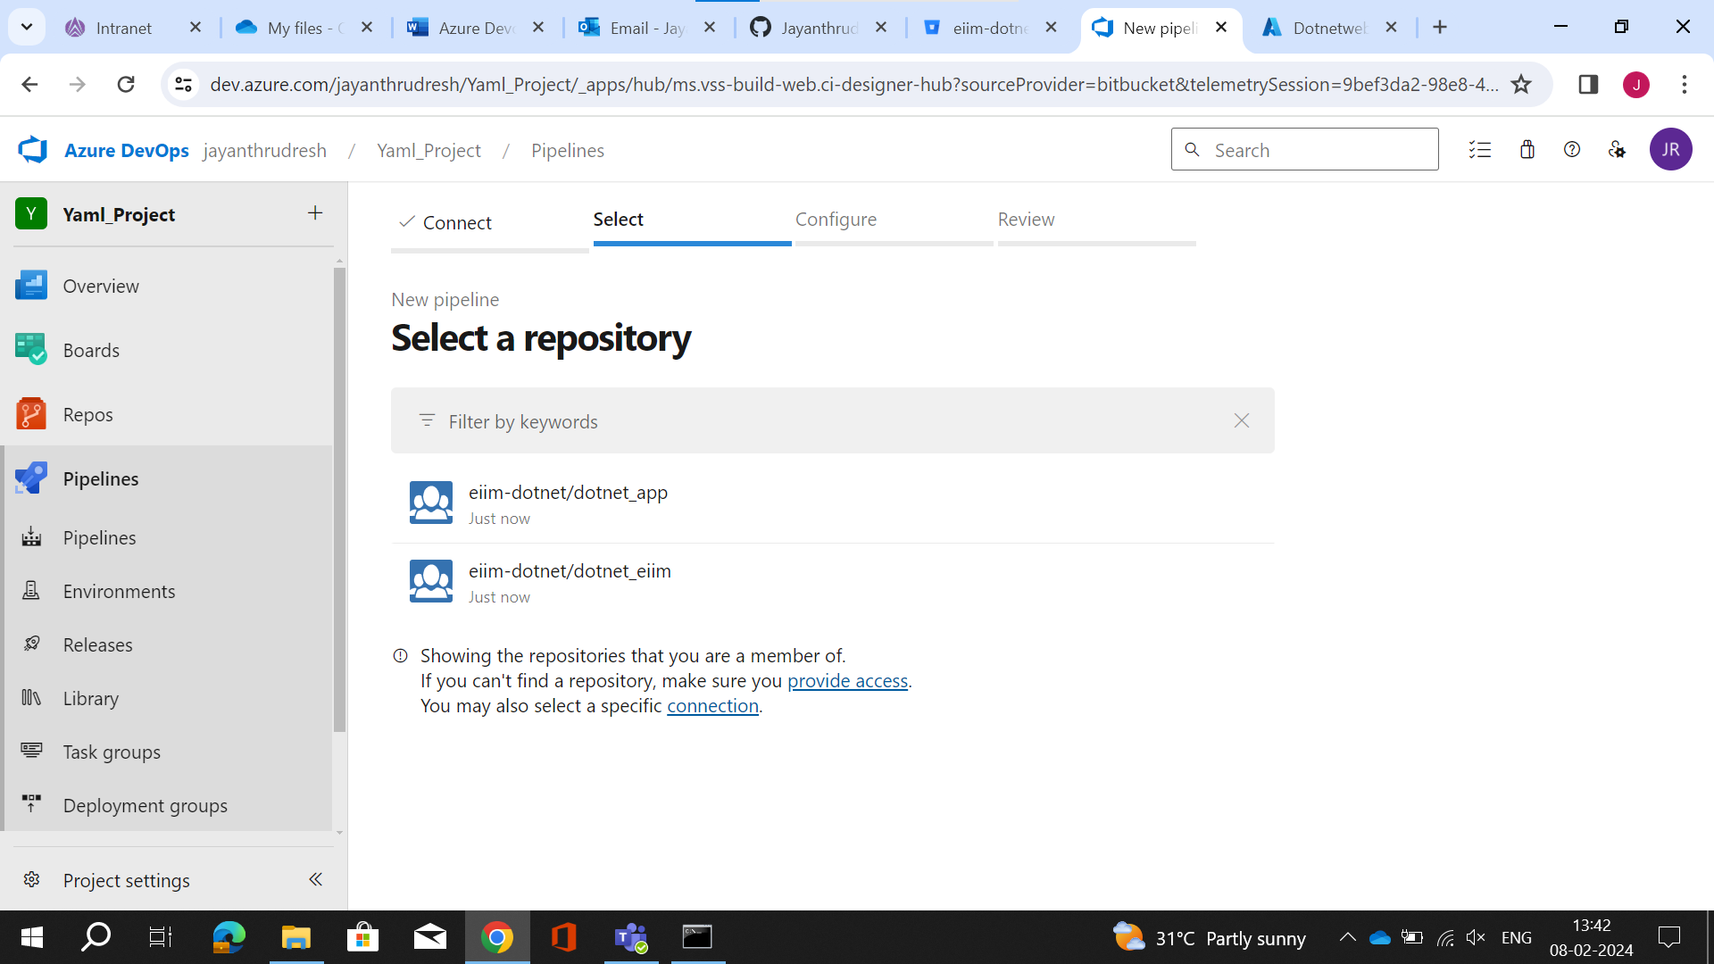

Now Create your own Yml file to add 2 jobs for build and deploy it, this is for build.

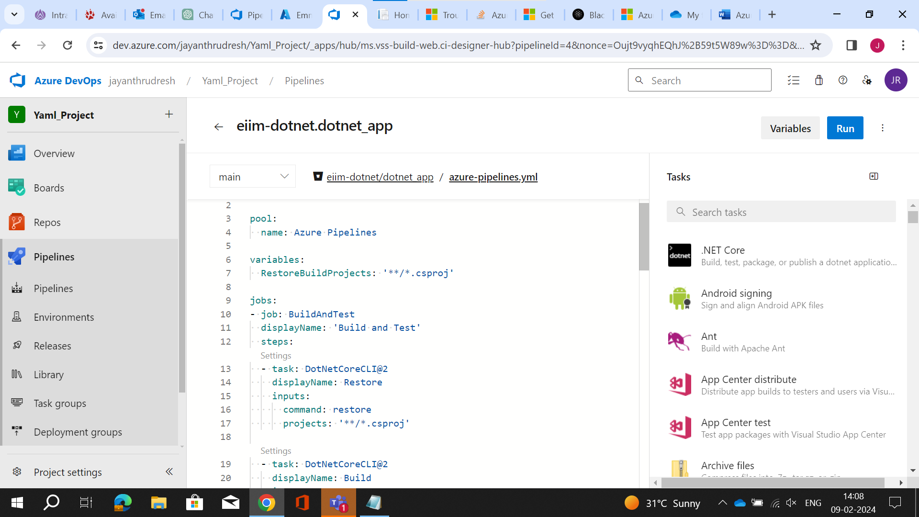

This is the deploy job in Yml.

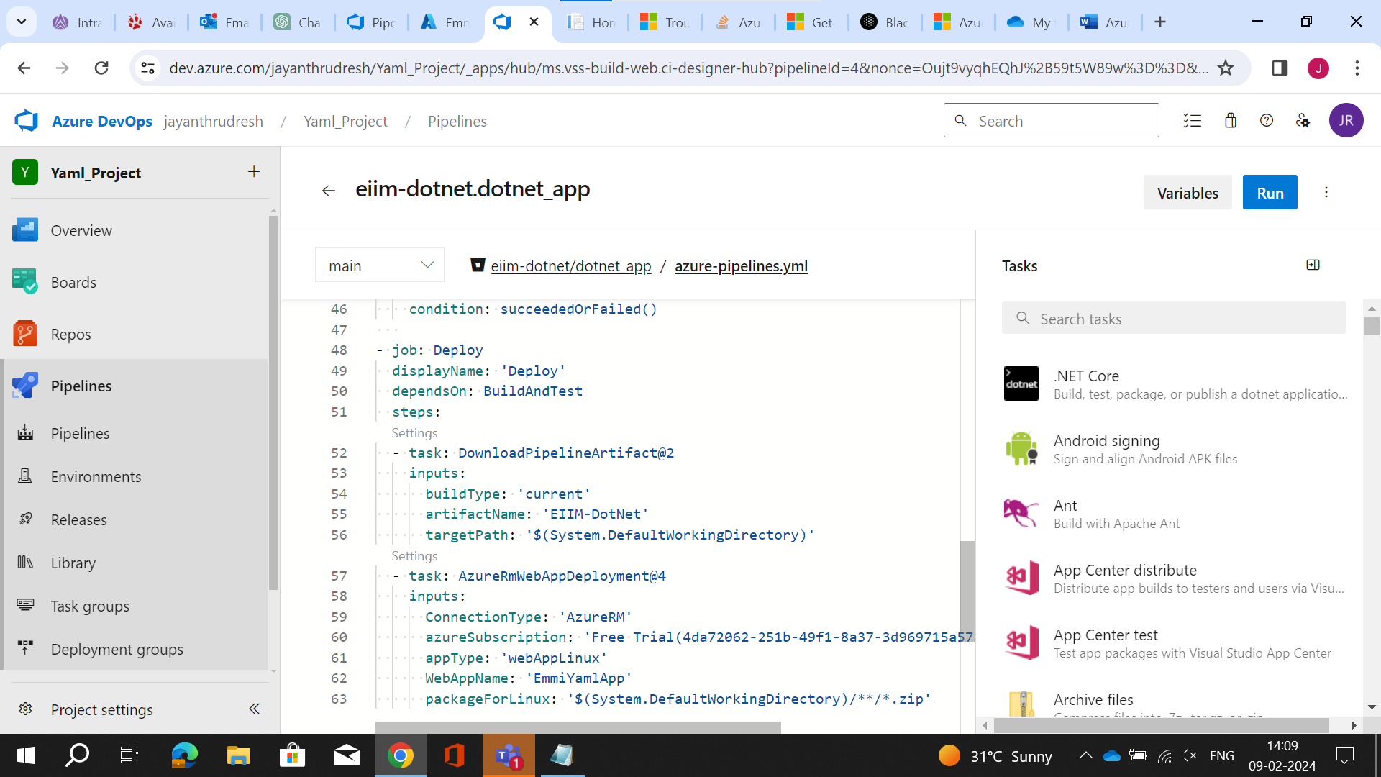

The Pipeline is ready and start the run here.

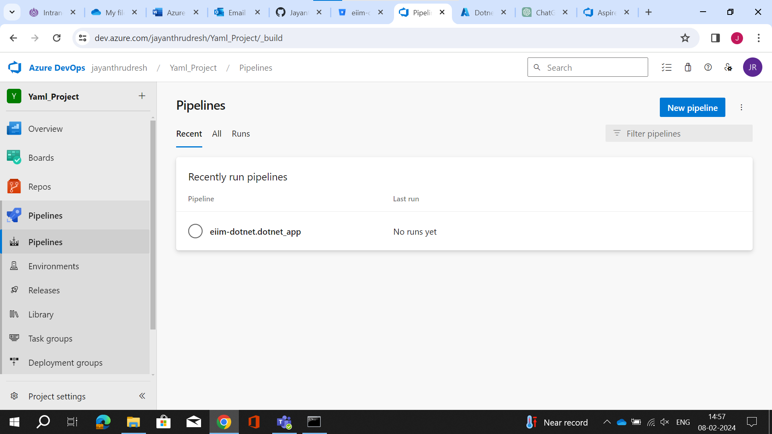

The yml file code is given as 2nd job should run if 1st job runs only.

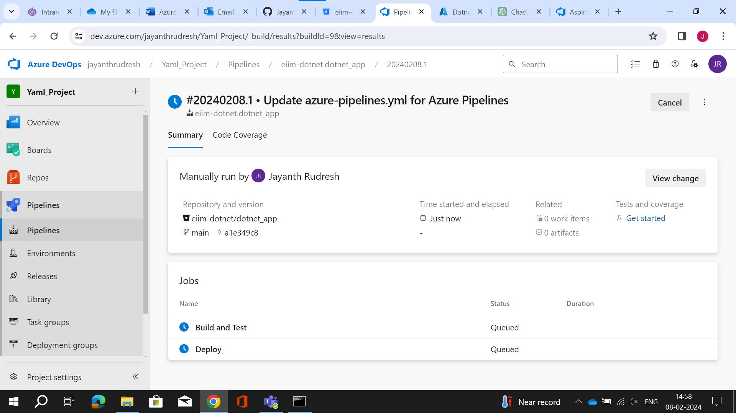

Now i have have to give access for a resource before running.

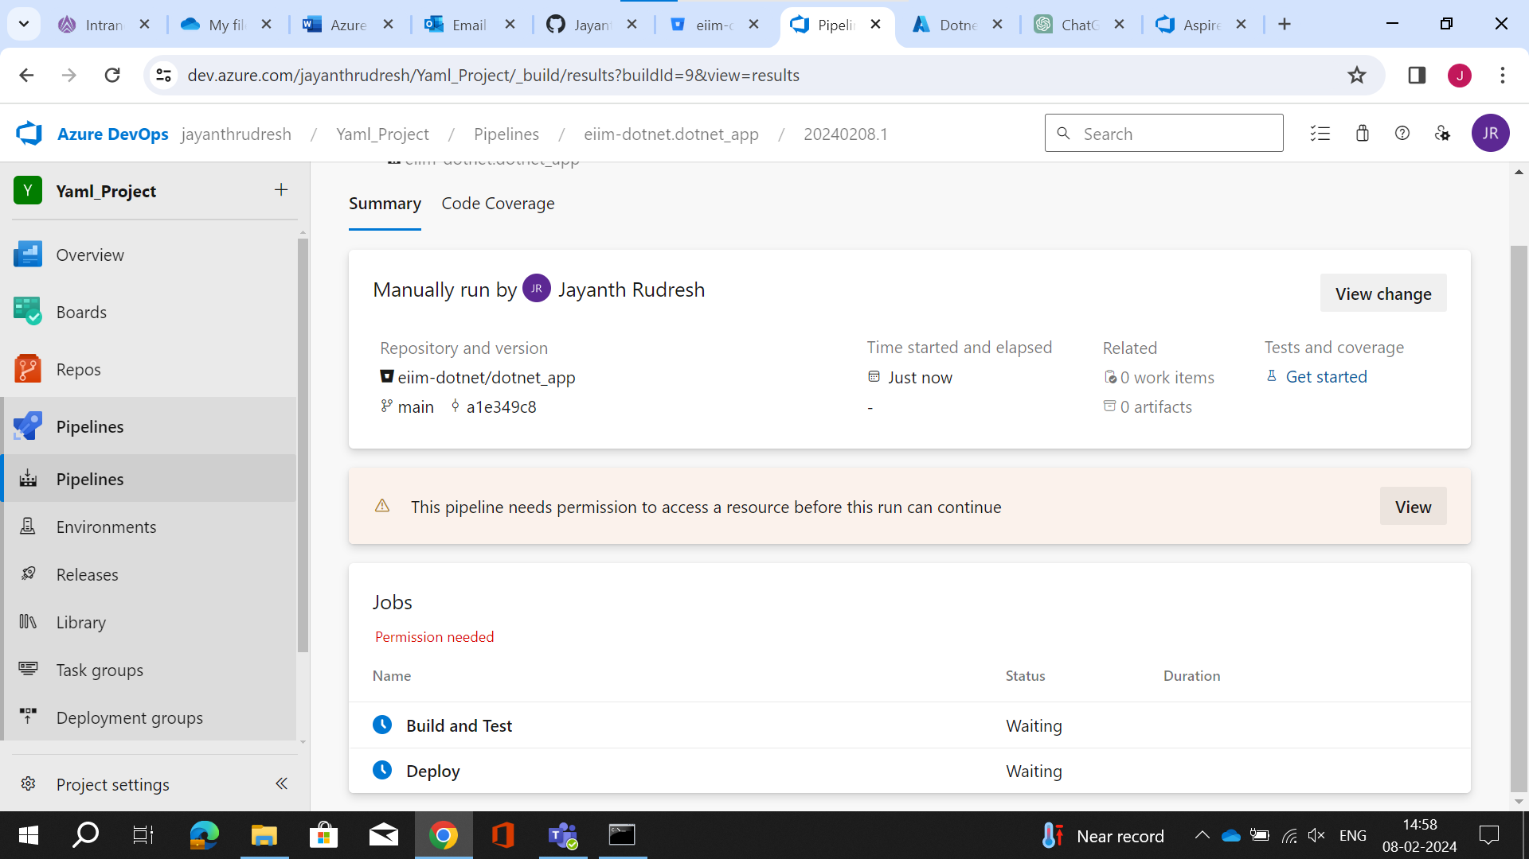

Permit Access.

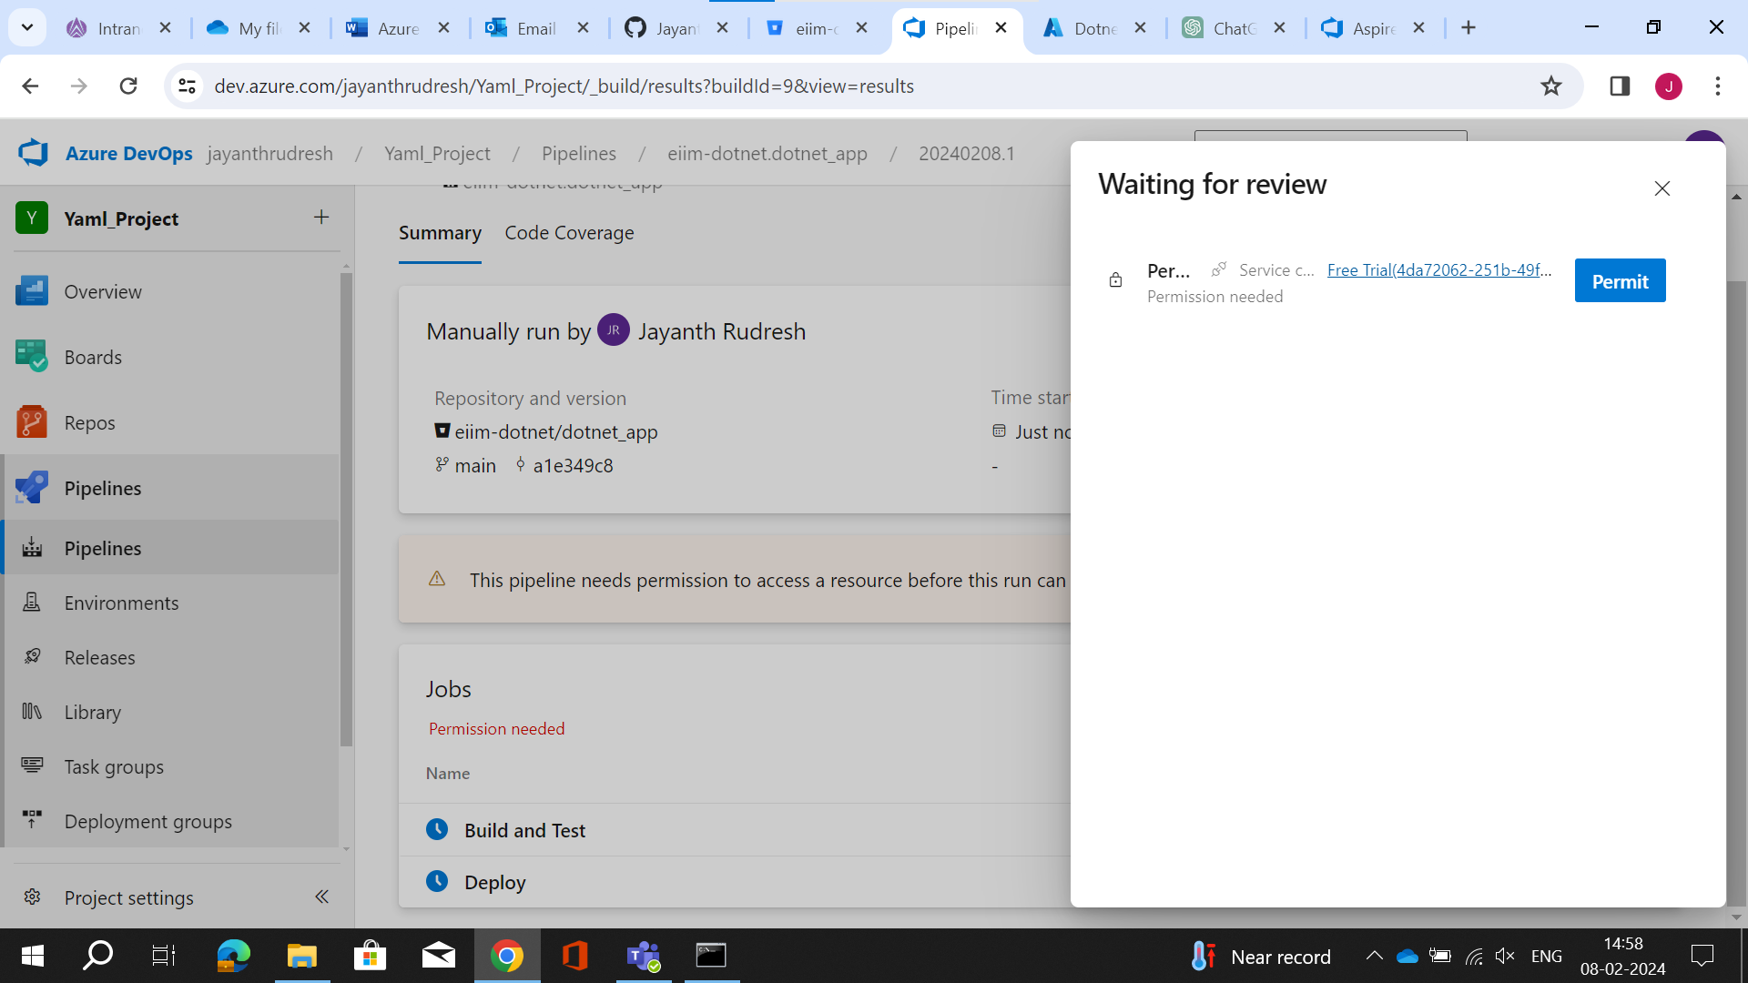

Permit.

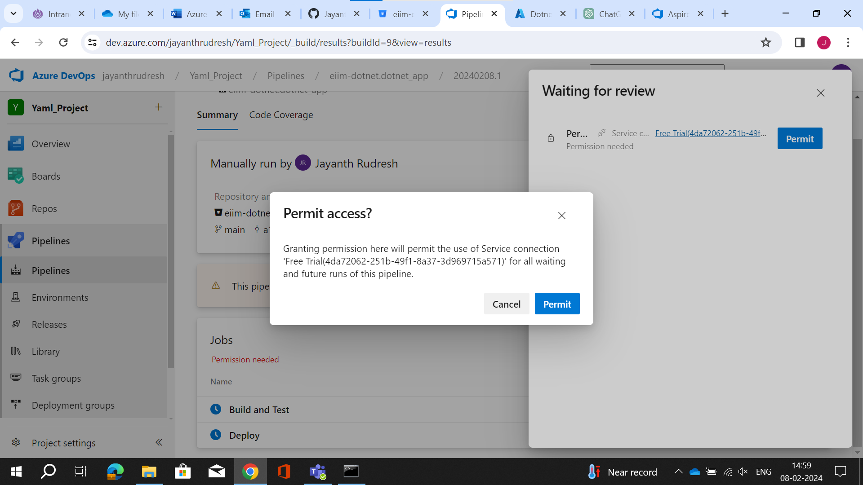

Now you can see here 1st job failed so 2nd job is stopped running.

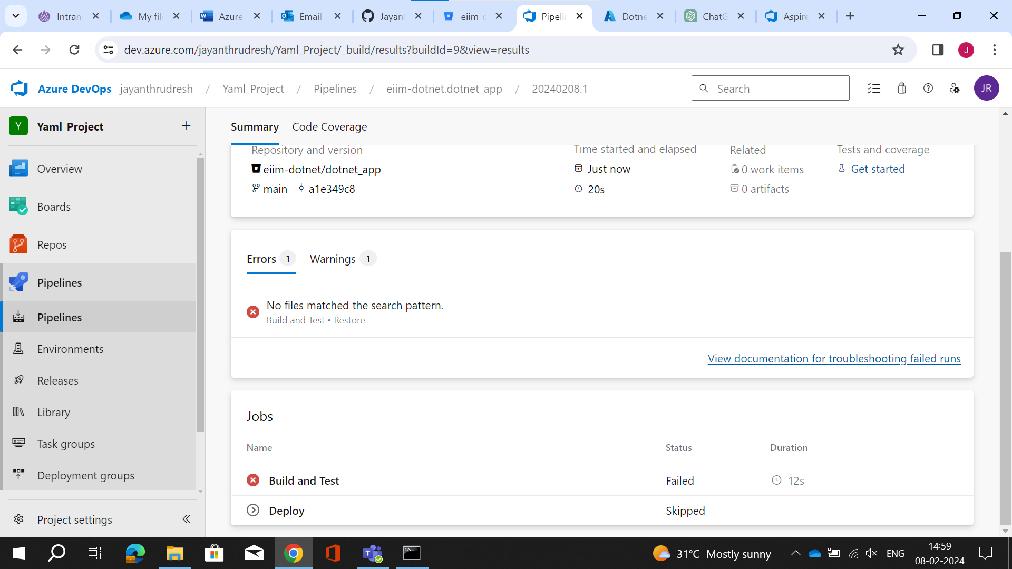

Here my 2 jobs also run successfully, and my application is successfully deployed

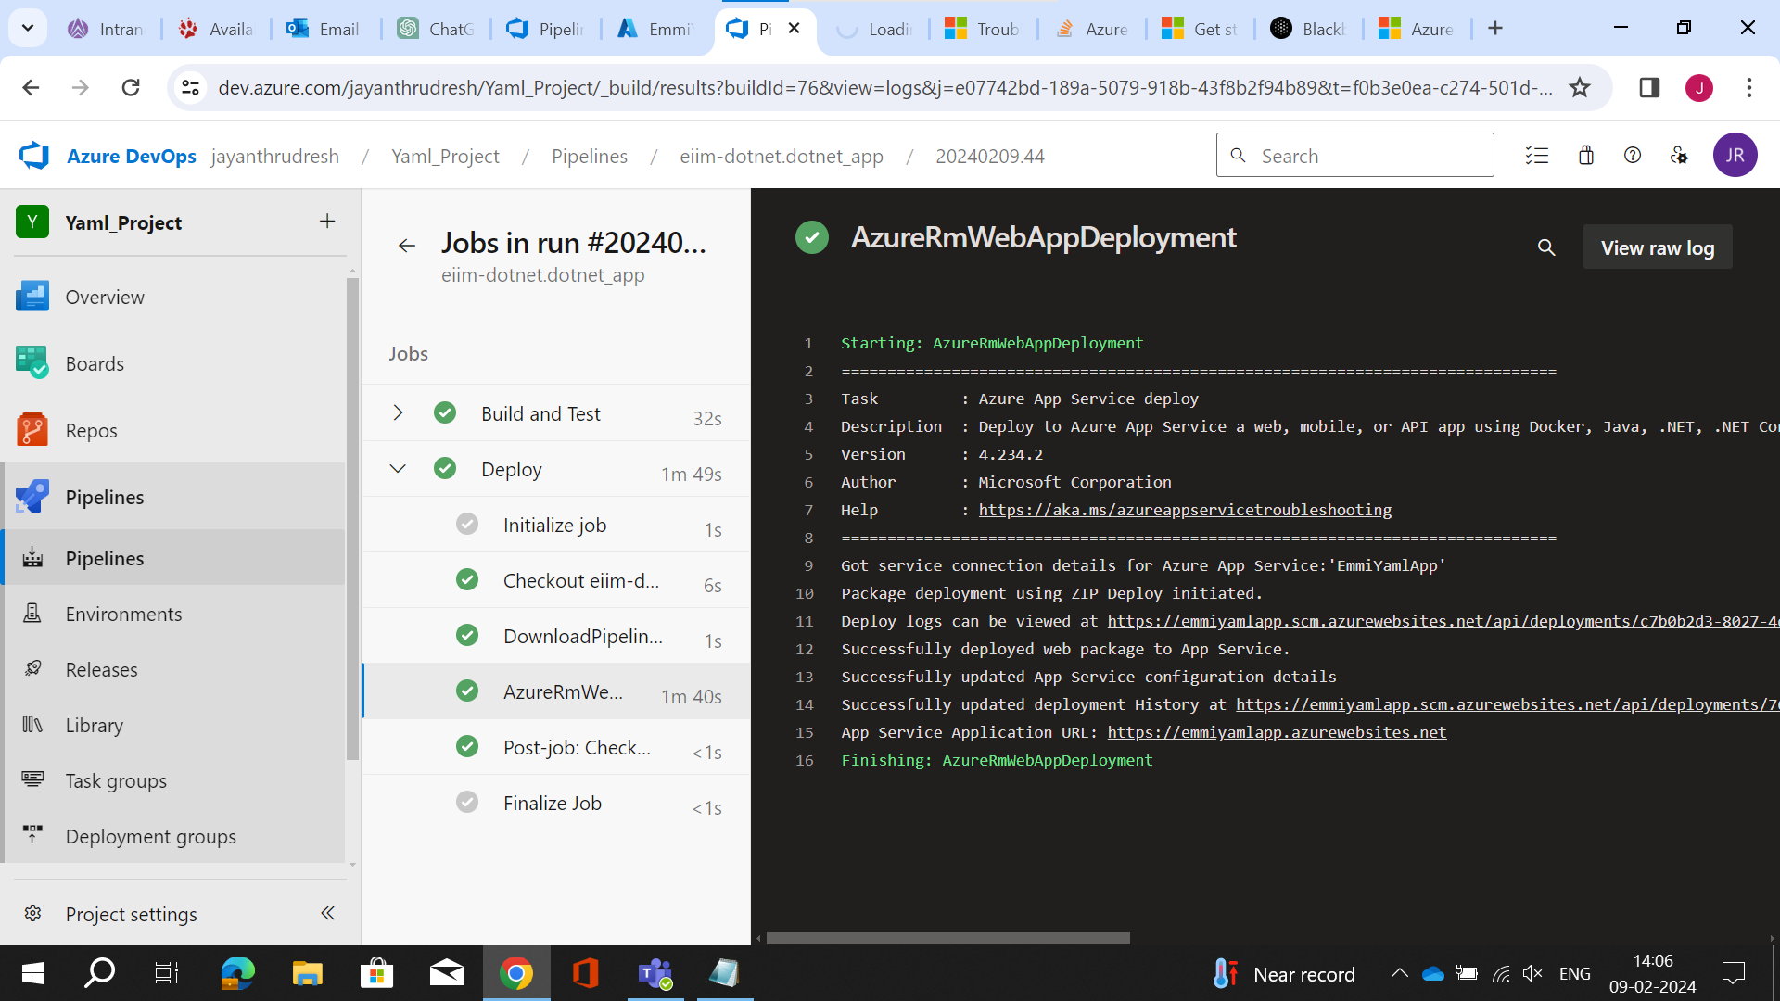

Now after Navigating to that link We can see our web app running.

